**11.a) Create a VM instance using terraform**

Inorder to use terraform first we have to

- Install Cloud SDK

- Install terraform

- Install VS Studio

- Install terraform inside VS

Step 1 : Create Service account with role as project owner and generate json key for that account.

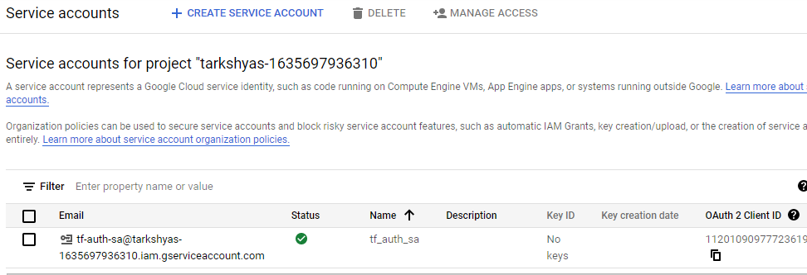

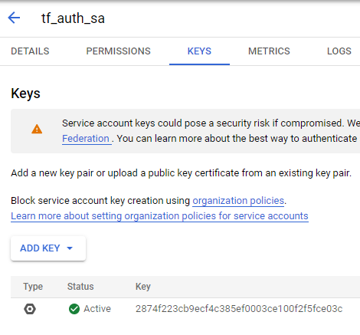

Step 2 : Open VS studio and create files such as provider.tf and vm.tf

Codes inside this files are attached with this document.

Step 3 : Keep the installed terraform , service account key , provider.tf and vm.tf in a same folder

Step 4 : Open cloud sdk and go to the path containing all these files

Step 5 : Now initiate gcloud inside sdk using command ‘init gcloud’

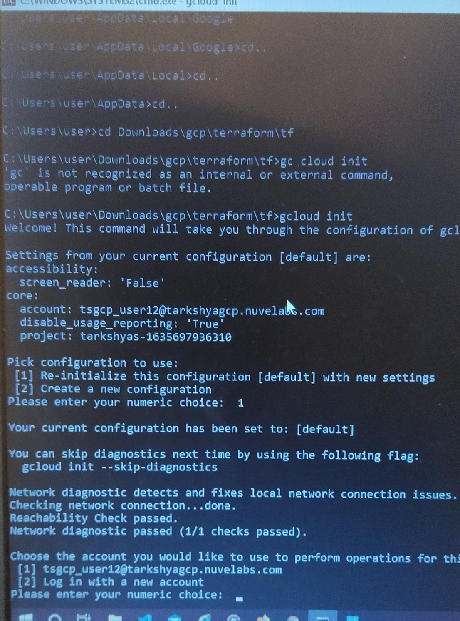

Step 6 : Use ‘terraform init’ command to initialize a working directory containing Terraform configuration files.

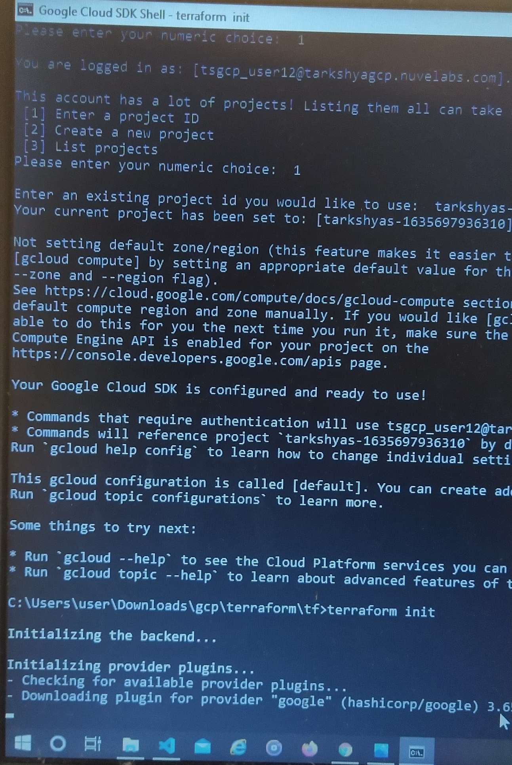

Step 7 : Use ‘terraform plan’ to evaluate a terraform configuration to determine the desired state of all the resources it declares, then compares that desired state to the real infrastructure objects being managed with the current working directory and workspace.

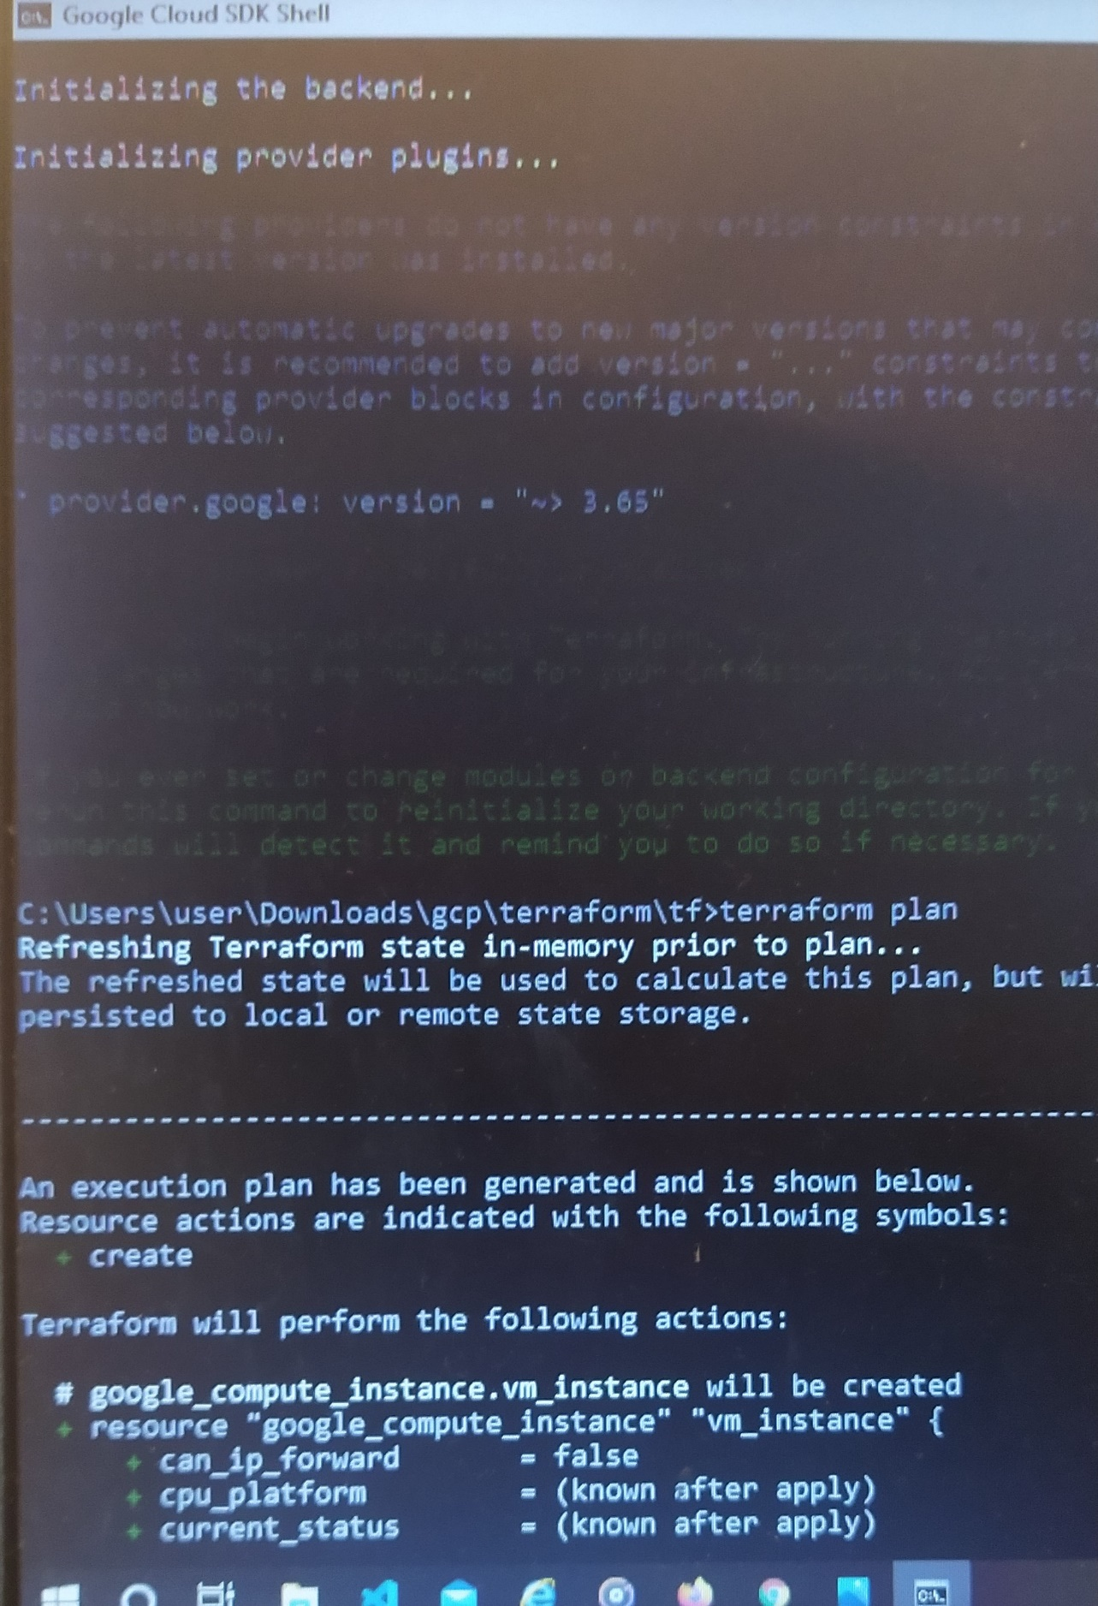

Step 8 : Use ‘terraform apply’ to execute the actions proposed in terraform plan.

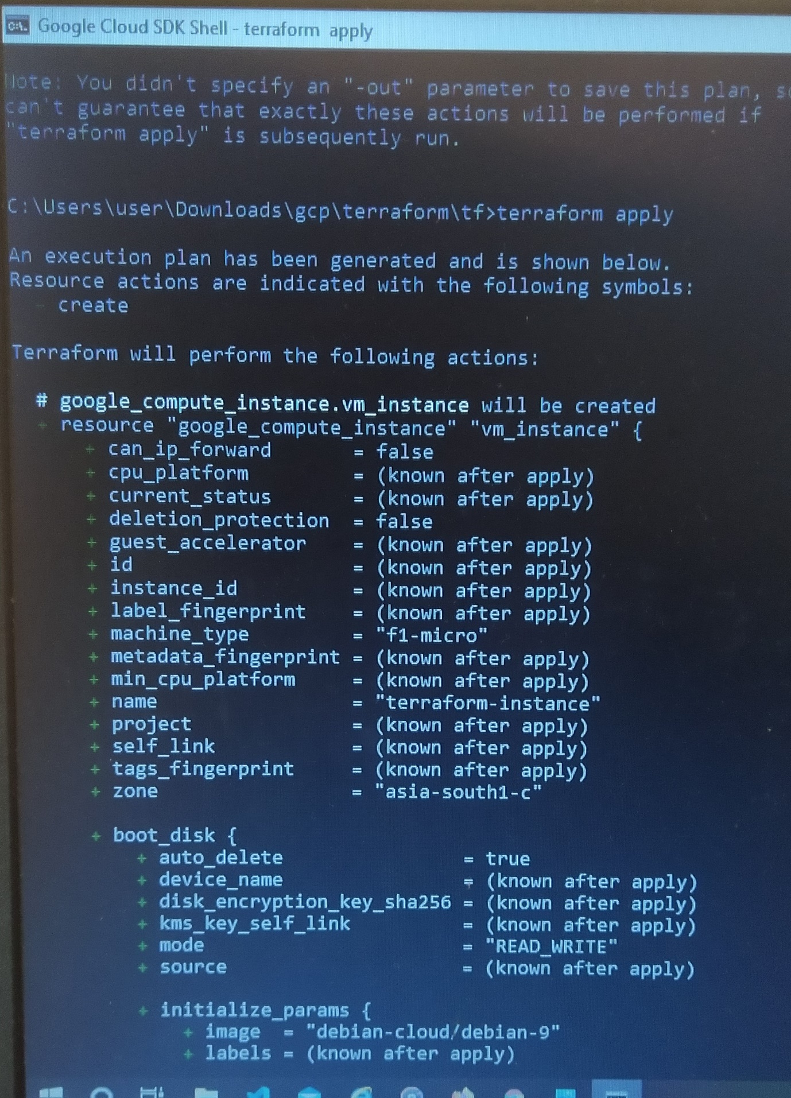

Step 9 : Go to VM instance and check whether the instance is created.

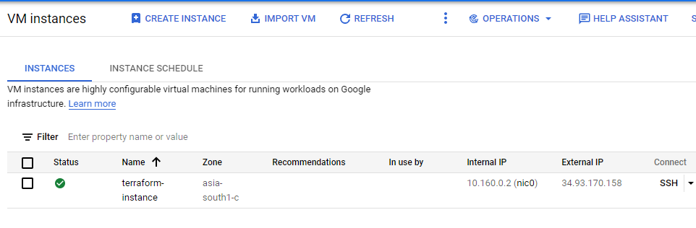

Step 10 : If we want to delete the created instance , use the command ‘terraform destroy’

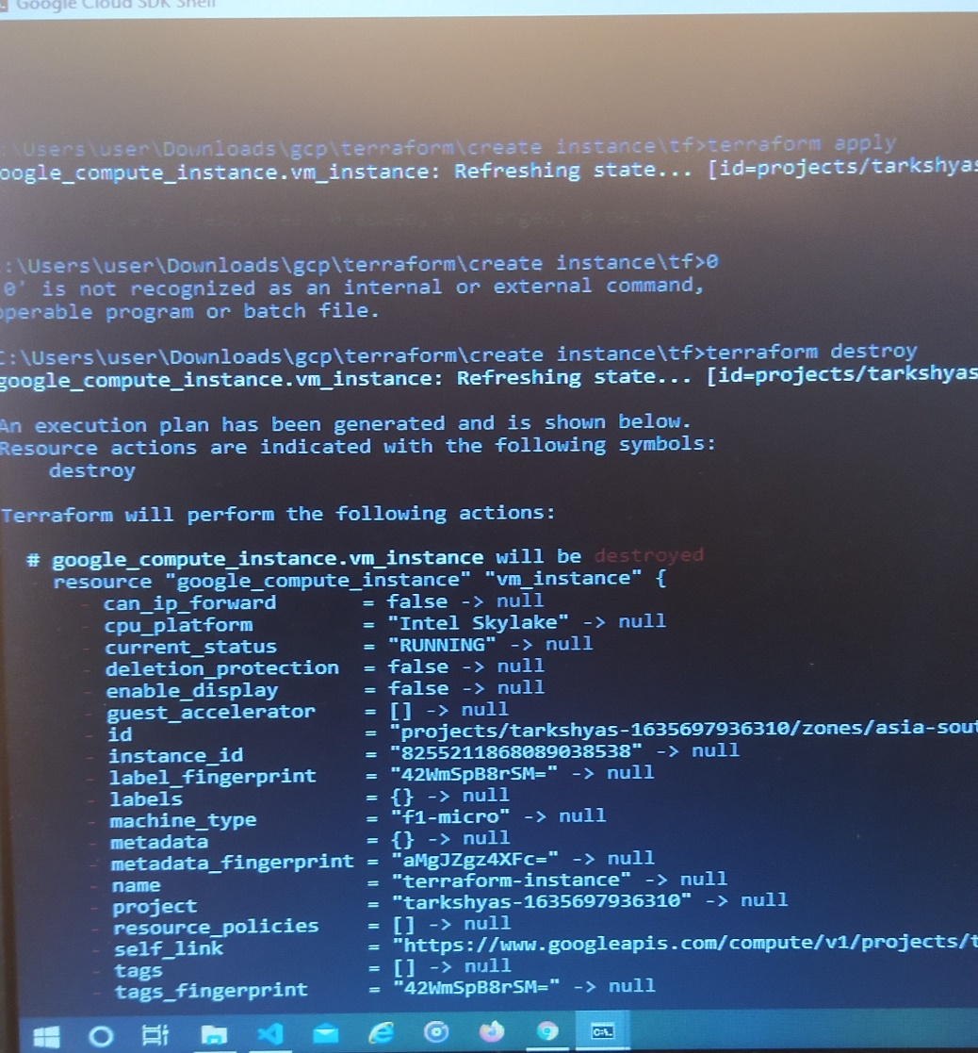

Step 11 : VM instance is deleted.

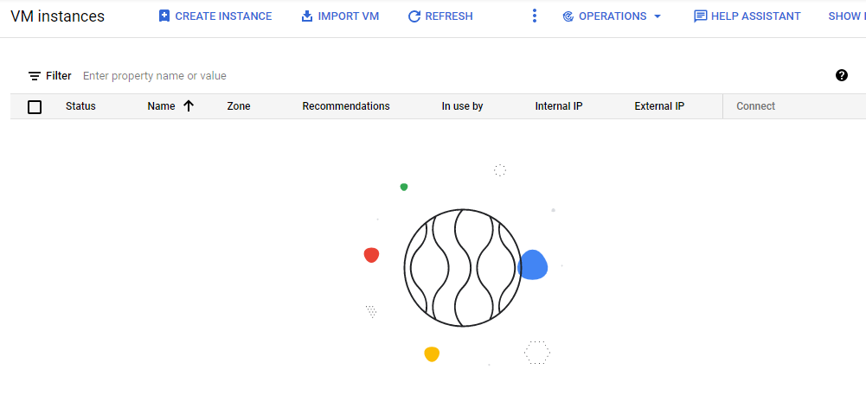

**11.b) Create a SQL instance using terraform**

Step 1 : Create Service account with role as project owner and generate json key for that account . Same as in VM instance creation.





Step 2 : Open VS studio and create files such as provider.tf and sql.tf

Codes inside this files are attached with this document.

Step 3 : Keep the installed terraform , service account key , provider.tf and sql.tf in a same folder

Step 4 : Open cloud sdk and go to the path containing all these files

Step 5 : Now initiate gcloud inside sdk using command ‘init gcloud’



Step 6 : Run terraform init

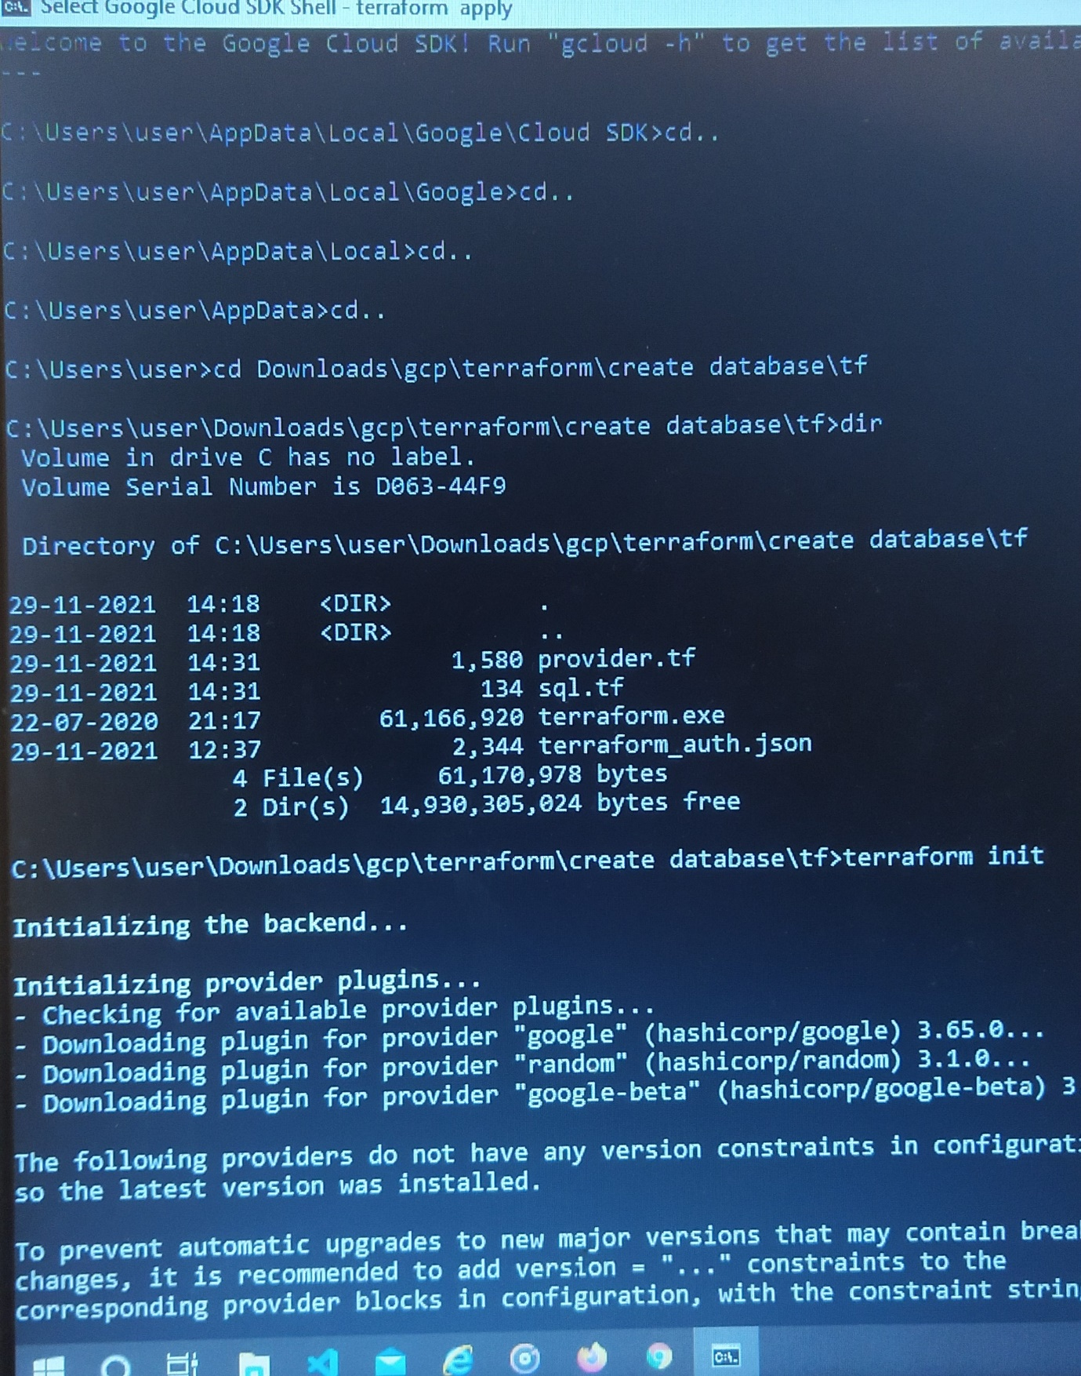

Step 7 : Run terraform plan

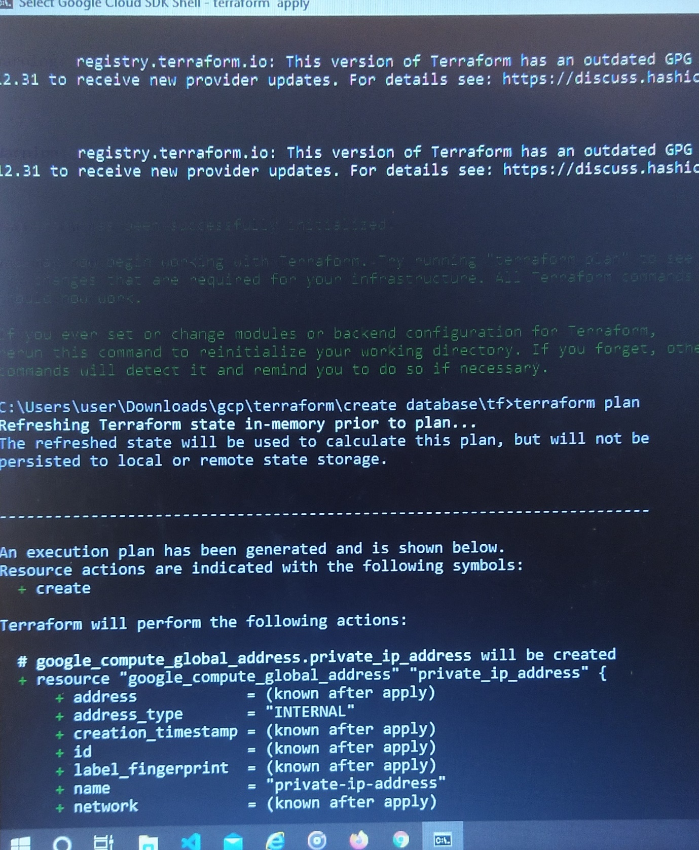

Step 8 : Run terraform apply

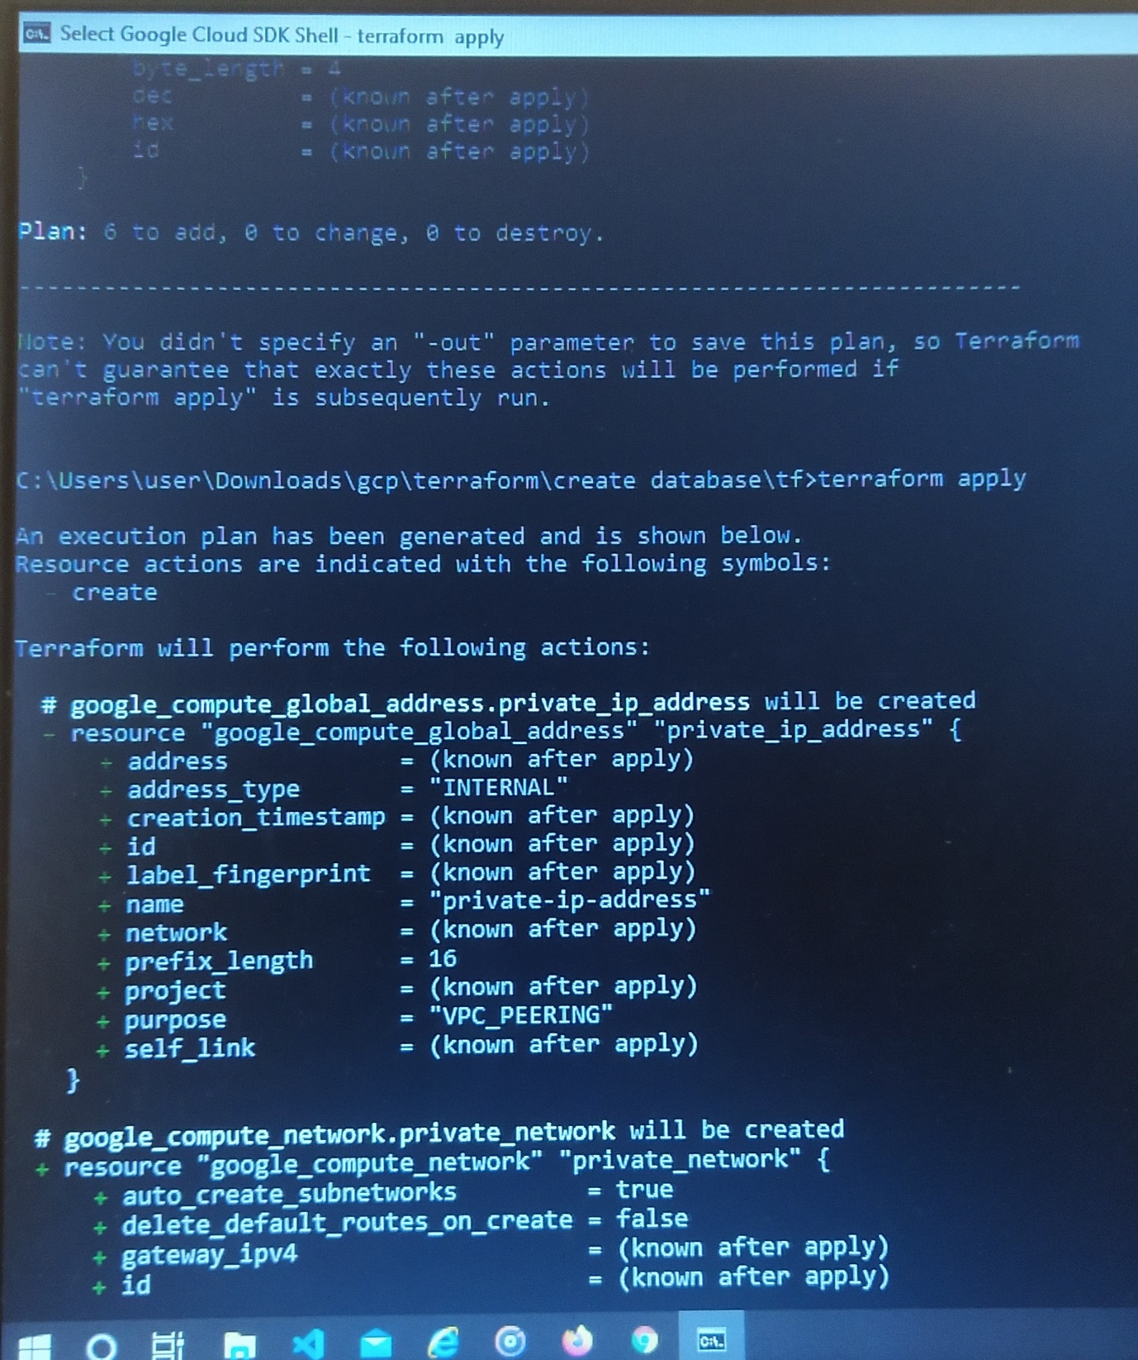

Step 9 : SQL instance created with database

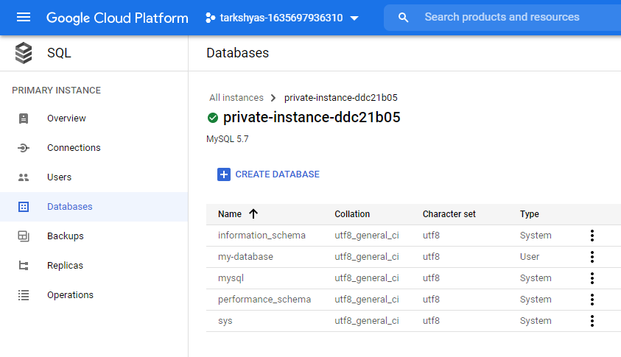

Step 10 : Run terraform destroy

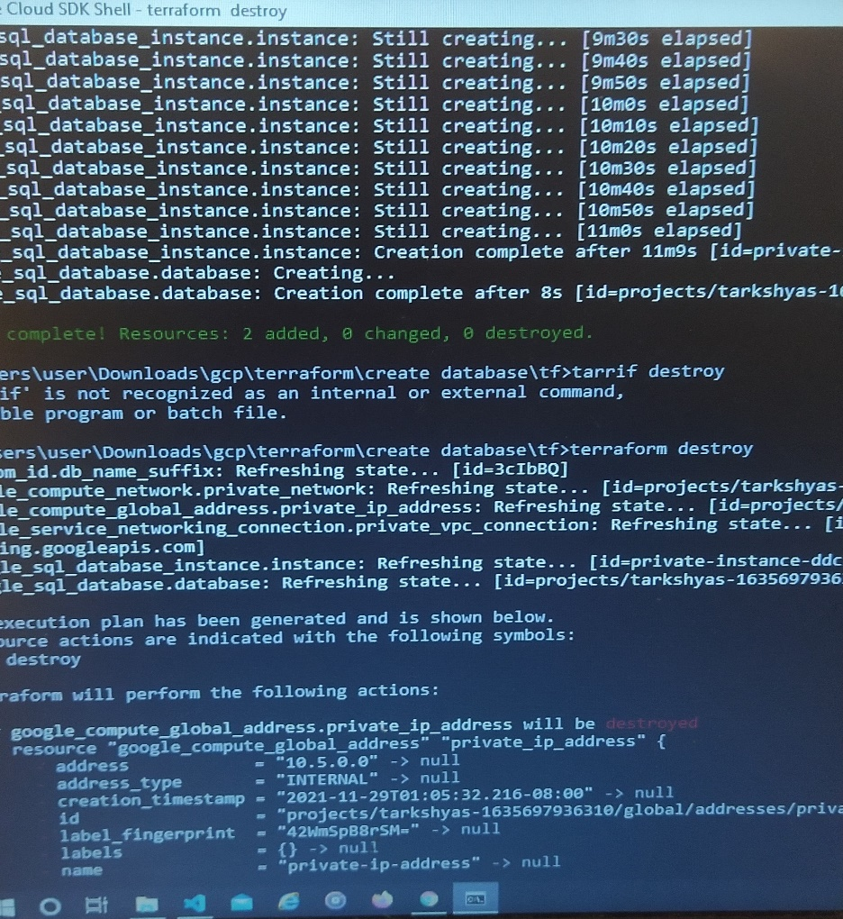

Step 11 : SQL instance deleted

